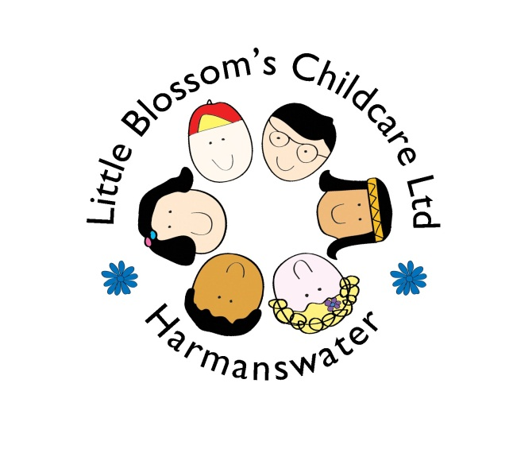
The Parks Community Centre
8 – 10 Nicholson Park
Bracknell
Berkshire
RG12 9QN
07754807784

 | Breakfast session | Morning  session | lunch  session  (if adding onto an am/pm) | Afternoon session | After school session
Monday | 8.30-9.00 | 9.00-12.00 | 12.00-12.30 | 12.00-3.00 | 3.00-3.30
Tuesday | 8.30-9.00 | 9.00-12.00 | 12.00-12.30 | 12.00-3.00 | 3.00-3.30
Wednesday | 8.30-9.00 | 9.00-12.00 | 12.00-12.30 | 12.00-3.00 | 3.00-3.30
Thursday | 8.30-9.00 | 9.00-12.00 | 12.00-12.30 | 12.00-3.00 | 3.00-3.30
Friday | 8.30-9.00 | 9.00-12.00 | 12.00-12.30 | 12.00-3.00 | 3.00-3.30
Cost if not funded | £5 | £19.50 | £4 | £19.50 | £4

Funding will be available a term after your child’s third birthday, we also accept 30 hours funding.
If you think you are entitled to 2 year funding and you haven’t already applied please contact me. We accept childcare voucher’s, please check with your employer whether they offer this.

